GEN ID: 21529073

**Employee Security Policies Undertaking**

I, Mousumi Ara Ahmed have received a copy of SRI-B “Security Policy – Summary Document” and I have read and understood clearly the same.

I agree to abide by the terms of the SRI-B Security Policy for users, any changes to it and any other related policies, guidelines and procedures that are issued from time to time.

Signature: 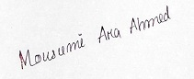

Date: 27/09/2021

Registered Office:# 2870, Phoenix Building, Bagmane Constellation Business Park, Outer Ring Road,Doddanekundi Circle, Marathahalli Post,Bangalore- 560 0037.

Tel :+91-80-3341 3000, Fax :+91-80-3341 3001, CIN: U72200KA2004PTC035309